

**Looping Statements**

**Dhruvin Dholiya**



1. **Write C program to print 1 to 10 number.**

* **Code:**

#include<stdio.h>

int main() {

int i;

for (i=1; i<= 10; i++) {

printf("%d\n", i);

}

return 0;

}

* **Output:**

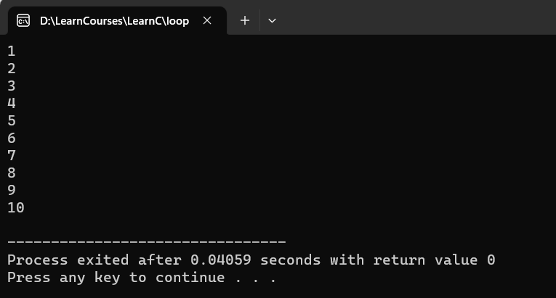

1. **Write C program to print 40 to 31 number.**

* **Code:**

#include<stdio.h>

int main() {

int i;

for (i=40; i>= 31; i--) {

printf("%d\n", i);

}

return 0;

}

* **Output:**

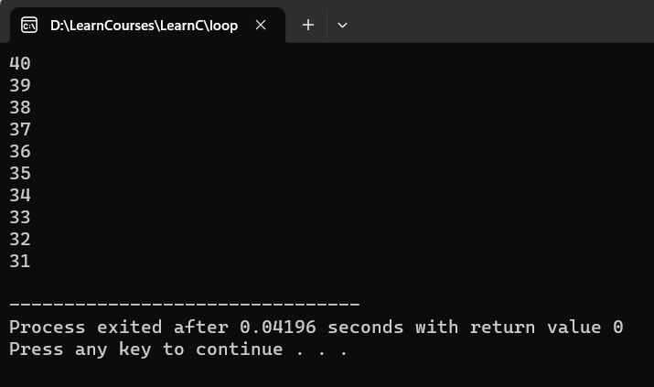

1. **Write C program to print odd number from 80 to 100.**

* **Code:**

#include<stdio.h>

int main() {

int i;

for (i=80; i<= 100; i++) {

if (i % 2 == 1) {

printf("%d\n", i);

}

}

return 0;

}

* **Output:**

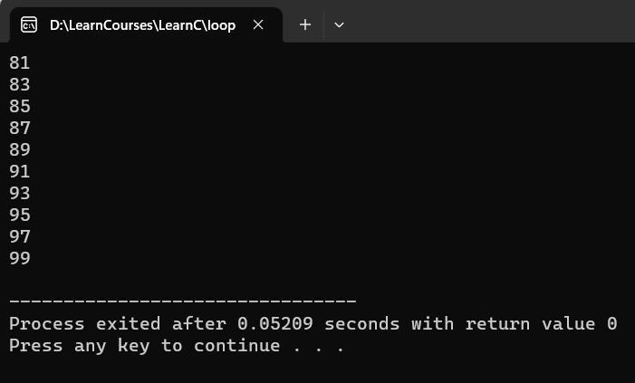

1. **Write C program to print number that are divisible by 5 from 25 to 50 number.**

* **Code:**

#include<stdio.h>

int main() {

int i;

for (i=25; i<= 50; i+=5) {

printf("%d\n", i);

}

return 0;

}

* **Output:**

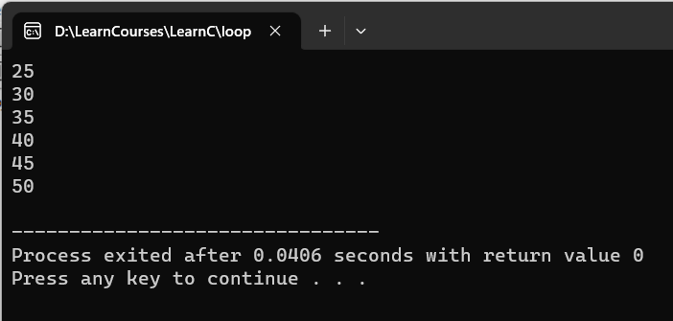

1. **Write C program to print to print A to Z character.**

* **Code:**

#include<stdio.h>

int main() {

char i;

for (i='A'; i<='Z'; i++) {

printf("%c\n", i);

}

return 0;

}

* **Output:**

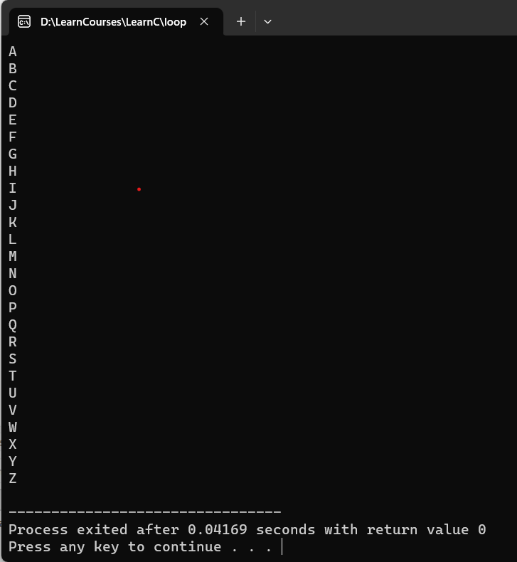

1. **Write C program to print multiplication table of any number.**

* **Code:**

#include<stdio.h>

int main() {

int i, num;

printf("Please enter any number: ");

scanf("%d", &num);

for (i=1; i<=10; i++) {

printf("%d * %d = %d\n", num, i, num*i);

}

return 0;

}

* **Output:**

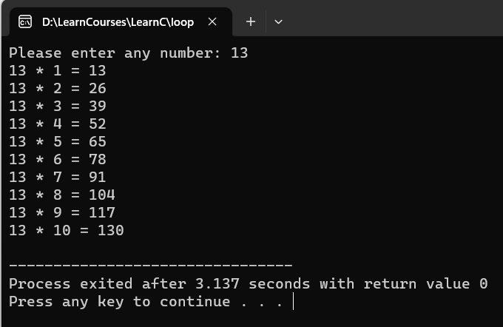

1. **Write C program to count number of boys whose weight is less than 50kg and height is greater than 170cm.**

* **Code:**

#include<stdio.h>

int main() {

int i, count=0, students;

float height, weight;

printf("Please enter count of students in your school: ");

scanf("%d", &students);

for (i=1; i<=students; i++) {

printf("Please enter weight and height: ");

scanf("%f %f", &weight, &height);

if (weight <= 50 && height >= 170) {

count++;

}

}

printf("Count of boys is: %d", count);

return 0;

}

* **Output:**

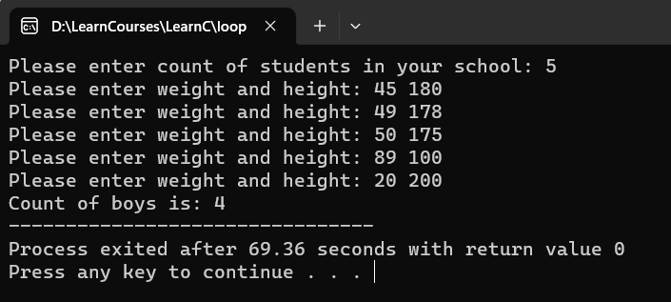

1. **Write C program to find ratio of (a-b) and (c-d) of any three number. If c and d is equal than not to find ratio.**

* **Code:**

#include<stdio.h>

int main() {

int i, a, b, c, d;

float ans;

for (i=1; i<=3; i++) {

printf("Please enter any four numbers: ");

scanf("%d %d %d %d", &a, &b, &c, &d);

if (c == d) {

printf("Ratio is not possible");

} else {

ans = (a-b) / (c-d);

printf("Ans: %f\n", ans);

}

}

return 0;

}

* **Output:**

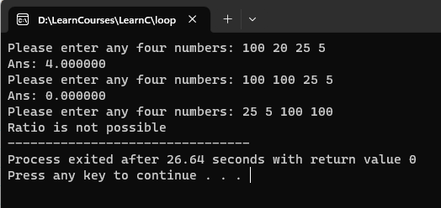

1. **Write C program to calculate factorial of a number.**

* **Code:**

#include<stdio.h>

int main() {

int i, num, fact=1;

printf("Please enter any number: ");

scanf("%d", &num);

for (i=num; i>=1; i--) {

fact = fact*i;

}

printf("\nThe Factorial of %d is: %d", num, fact);

return 0;

}

* **Process**:

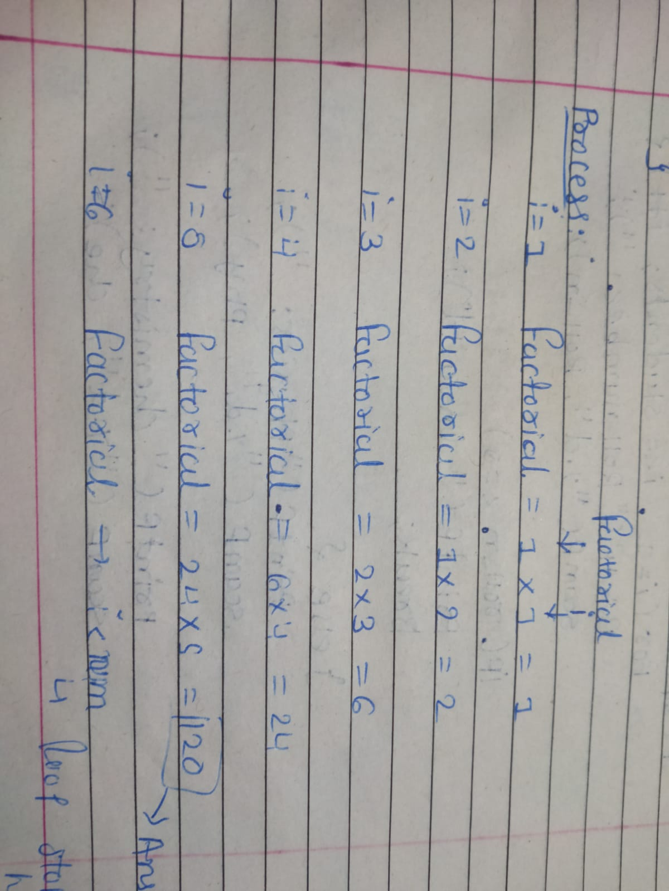

* **Output:**

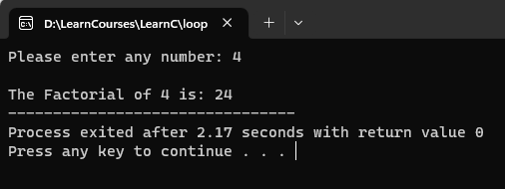

1. **Write C program to give sum of n numbers.**

* **Code:**

#include<stdio.h>

int main() {

int i, num, sum=0;

printf("Please enter any number: ");

scanf("%d", &num);

for (i=1; i<=num; i++) {

sum = sum + i;

}

printf("\nThe sum of %d is: %d", num, sum);

return 0;

}

* **Process**:

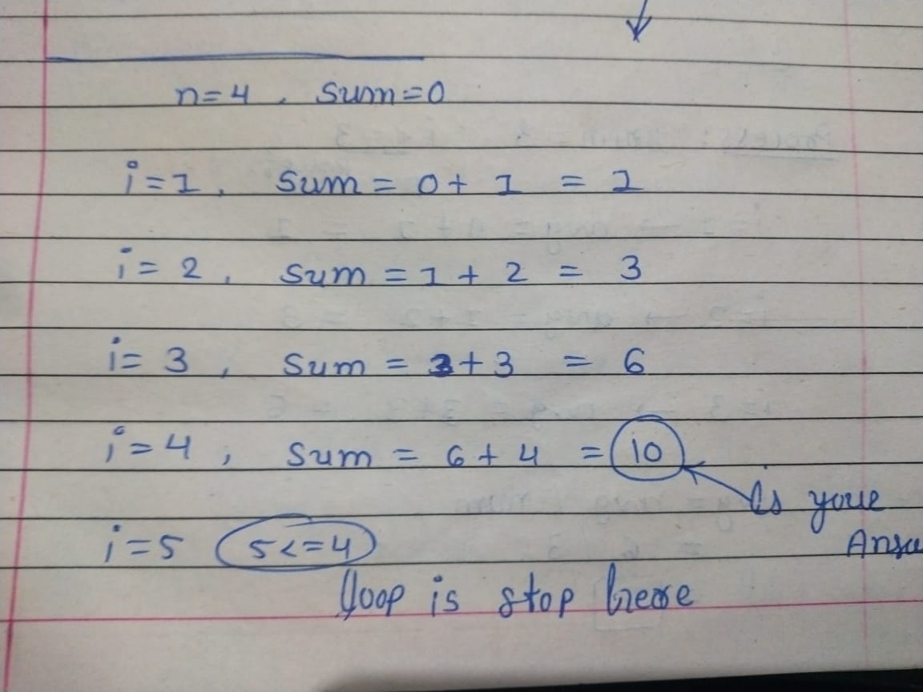

* **Output:**

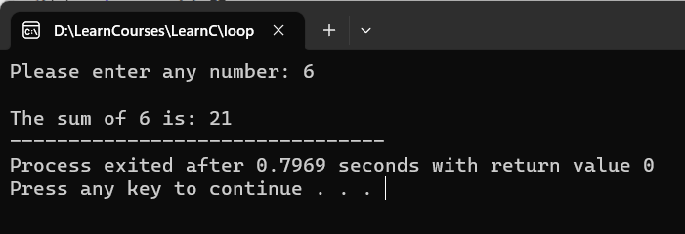

1. **Write C program to give average of n numbers.**

* **Code:**

#include<stdio.h>

int main() {

int i, num;

float avg;

printf("Please enter any number: ");

scanf("%d", &num);

for (i=1; i<=num; i++) {

avg = avg + i;

}

avg = avg / num;

printf("\nThe sum of %d is: %f", num, avg);

return 0;

}

* **Process**:

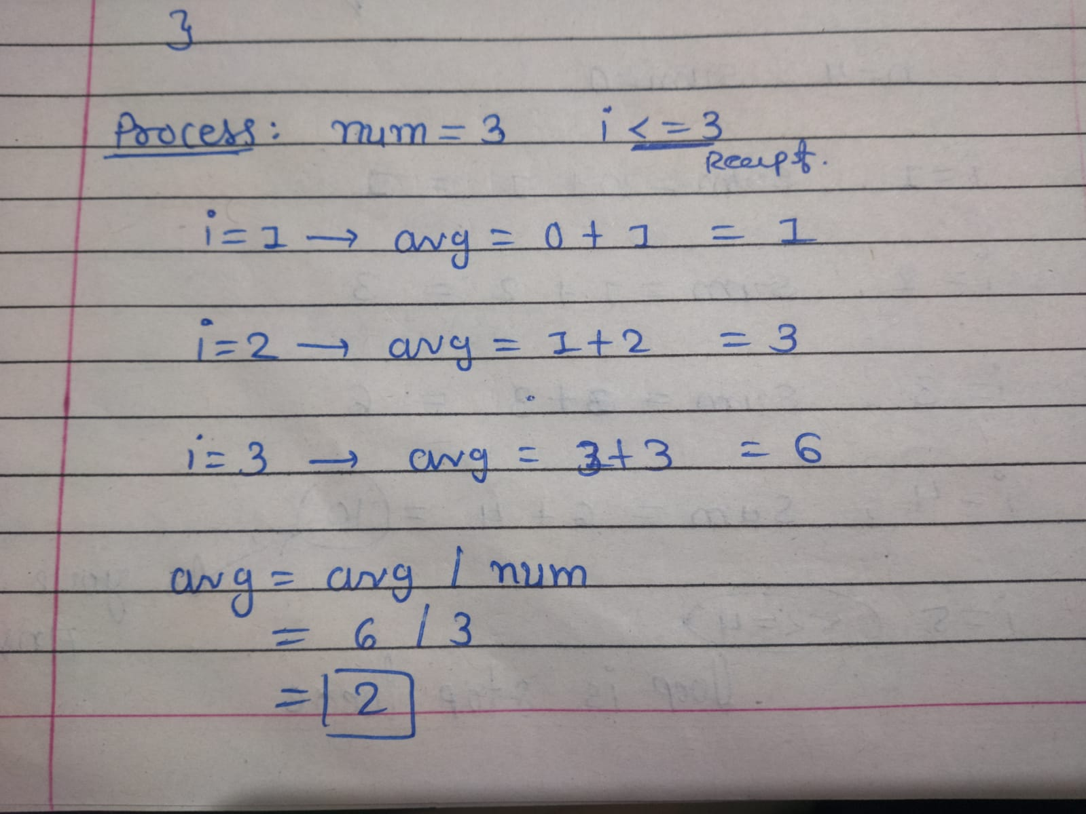

* **Output:**

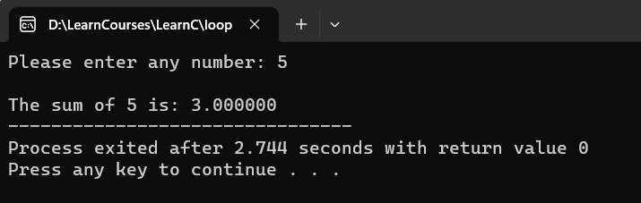

1. **Write C program to find a number that is divisible by 7 or 3 from n numbers.**

* **Code**

#include<stdio.h>

int main() {

int i, n, num;

printf("how many numbers do you want to check? : ");

scanf("%d", &n);

i = 1;

do {

printf("\nEnter number: ");

scanf("%d", &num);

if (num % 7 == 0 || num % 3 == 0) {

printf("%d is divisible\n", num);

} else {

printf("%d is not divisible\n", num);

}

i++;

} while (i <= n);

return 0;

}

* **Output**

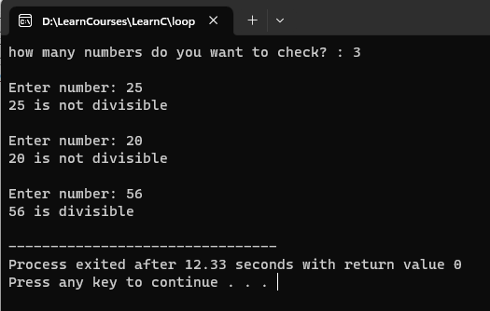

1. **Write C program to count number of digits in a number.**

* **Code**

#include<stdio.h>

int main() {

int n, counter=0;

printf("Please enter any number for count digit: ");

scanf("%d", &n);

while (n > 0) {

n = n/10;

counter++;

}

printf("The digit of your number is: %d", counter);

return 0;

}

* Process

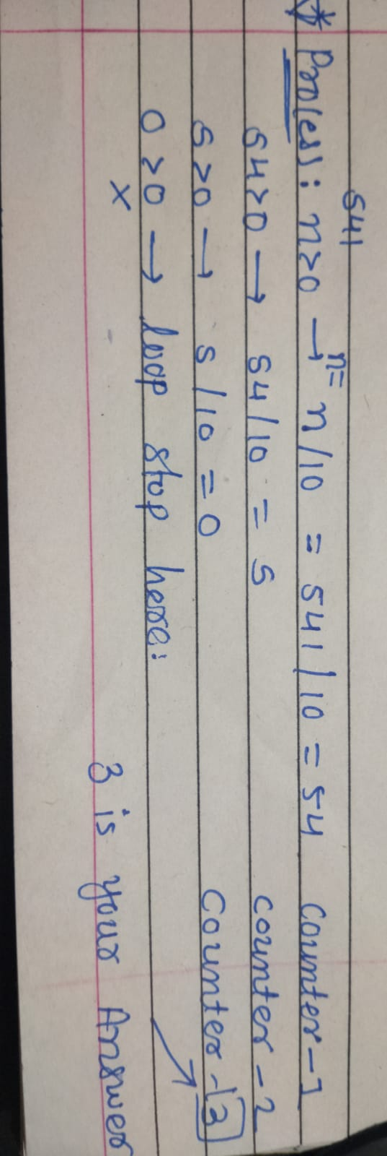

* **Output**

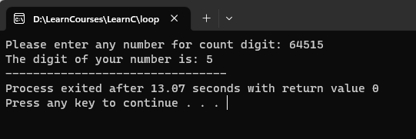

1. **Write C program to enter a number and print its reverse & check weather num is palindrome or not?**

* **Code**

#include<stdio.h>

int main() {

int n, rem, rev=0, org_num;

printf("Please enter any number for for make revers digit and find that number is palindrome or not.: ");

scanf("%d", &org_num);

n = org_num;

while (n > 0) {

rem = n % 10;

rev = rev * 10 + rem;

n = n/10;

}

printf("Revers number: %d\n\n", rev);

if (org_num == rev) {

printf("YES - Your added number is palindrome number.");

} else {

printf("NO - Your added number isn't palindrome number.");

}

return 0;

}

* Process

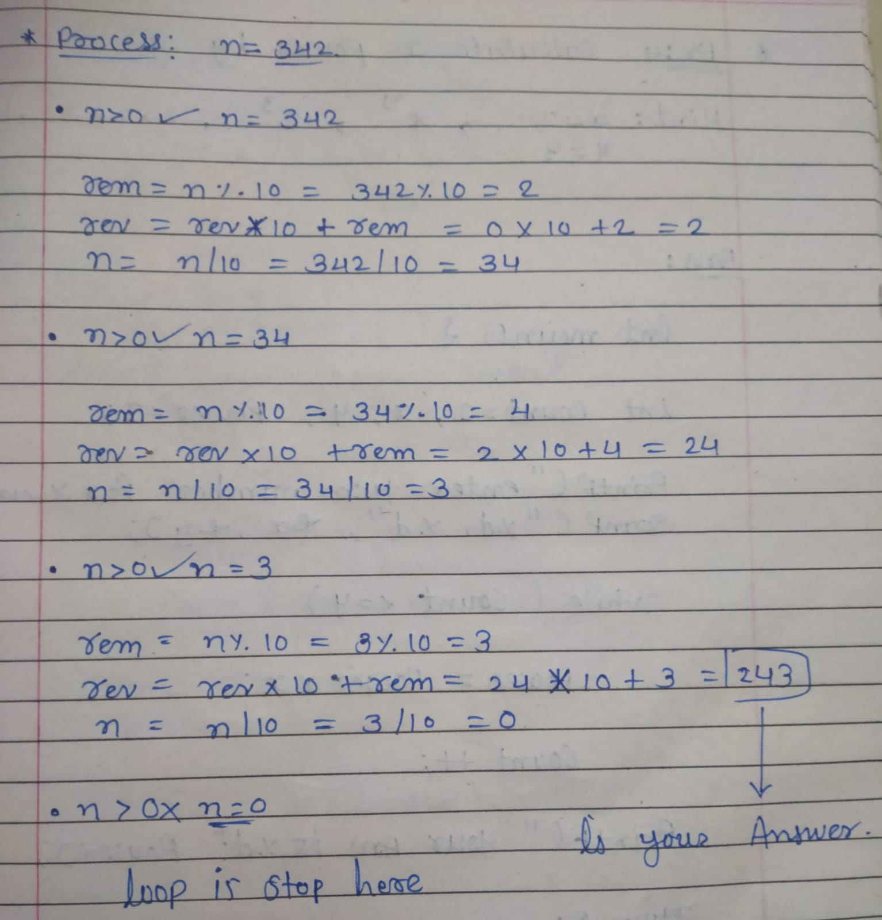

* **Output**

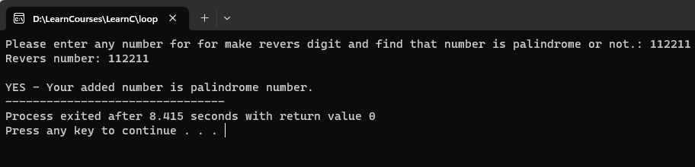

1. **Write C program to check number is prime or not.**

* **Code**

#include<stdio.h>

int main () {

int num, i, flag = 0;

printf("Please enter any number: ");

scanf("%d", &num);

if (num > 1) {

if (num == 2) {

printf("%d is prime number.", num);

} else {

for (i = 2; i < num; i++) {

if (num % i == 0) {

flag = 1;

break;

}

}

if (flag == 0) {

printf("%d is prime number", num);

} else {

printf("%d is not prime number", num);

}

}

} else {

printf("%d is should more than 1.");

}

return 0;

}

* **Process**

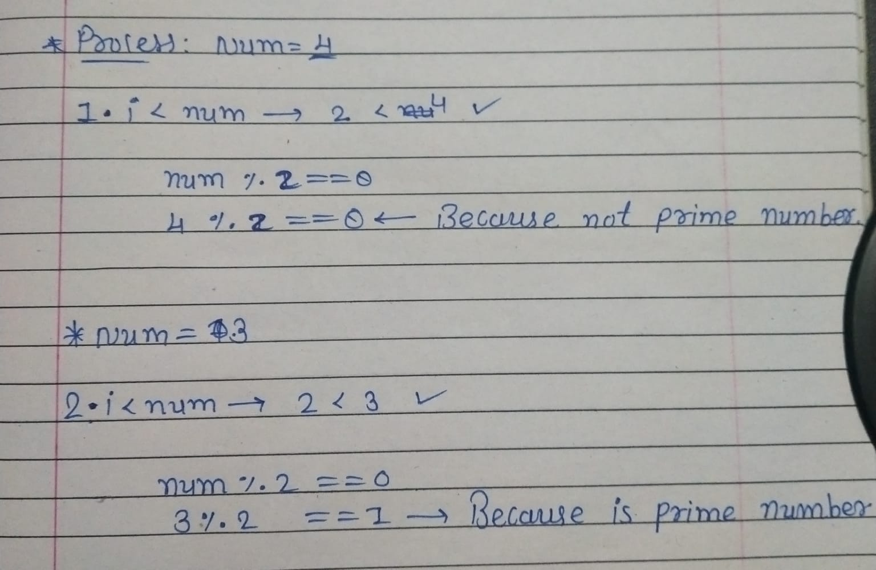

* **Output**

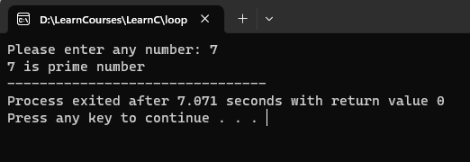

1. **Write C program to find class of the n students from their m marks.**   Note: 1. You have to take student's roll number and 5 subject marks out of 100.   
                 2. If total marks greater than 450 then grade will be A.  
                     If total marks greater than 350 then grade will be B.  
                     If total marks less than 350 then grade will be C.

* **Code**

#include<stdio.h>

int main () {

int i, students, roll_n, phy, chem, bio, eng, sans, sub_mark, totle_mark;

char grade;

printf("How many students who are you want to find the class by their marks?: ");

scanf("%d", &students);

if (students > 0) {

for (i = 1; i <= students; i++) {

printf("\nPlease enter roll number of student: ");

scanf("%d", &roll_n);

if (roll_n <= 0) {

printf("\nINVALID - Please check your added input.\n");

break;

} else {

printf("\nPlease enter marks out of 100 of given subject to below:\n");

printf("Physics: ");

scanf("%d", &phy);

printf("Chemistry: ");

scanf("%d", &chem);

printf("Biology: ");

scanf("%d", &bio);

printf("English: ");

scanf("%d", &eng);

printf("Sanskrit: ");

scanf("%d", &sans);

totle_mark = phy + chem + bio + eng + sans;

if (totle_mark > 450) {

grade = 'A';

} else if (totle_mark > 350 && totle_mark <= 450) {

grade = 'B';

} else if (totle_mark <= 350) {

grade = 'C';

} else if (totle_mark > 500) {

printf("INVALID - Please check your added input.");

}

printf("\nTotle marks: %d/500", totle_mark);

printf("\nGrade: %c", grade);

}

}

} else {

printf("\nINVALID - Please check your added input.");

}

return 0;

}

* **Output**

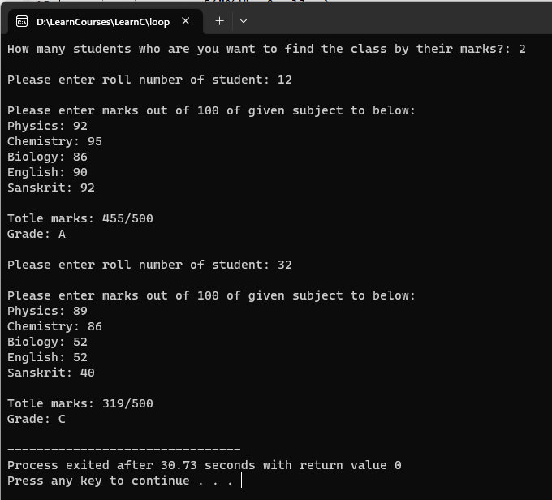

1. **Write C program to find expenses of an organization from n month.  
   Note:**   
    1. **You have to ask expense of electricity, salary and marketing of each month.  
    2. You have to print Month number and total expense of each month.**

* **Code**

#include<stdio.h>

int main () {

int i, month_from, month_to, salary, elec, mkt, total_exp;

printf("From which month you want to calculate the expenses: ");

scanf("%d", &month_from);

printf("To which month you want to calculate the expenses: ");

scanf("%d", &month_to);

if (month_from <= month_to) {

for (i = month_from; i <= month_to; i++) {

printf("\n-------\nMONTH:%d\n-------\n",i);

printf("Salary: Rs.");

scanf("%d", &salary);

printf("Electricity expense : Rs.");

scanf("%d", &elec);

printf("Marketing expense: Rs.");

scanf("%d", &mkt);

total_exp = salary + elec + mkt;

printf("\nYour monthly expense: Rs.%d/-\n", total_exp);

}

printf("\nYou can see here all your total monthly expenses month wise.\n");

for (i = month_from; i <= month_to; i++) {

printf("%d - Rs.%d/-\n", i, total_exp);

}

} else {

printf("Sorry - We can not calculate expense.");

}

return 0;

}

* **Output**

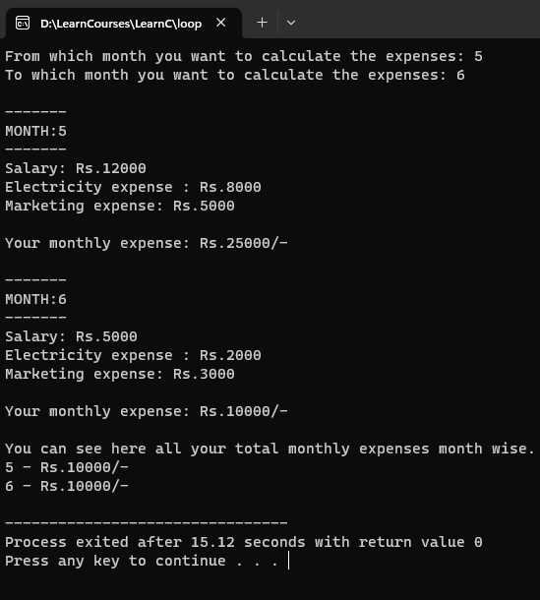

1. **Write a program to calculate x power y.(when user input x is 2 and y is 3 then the result will be 8)**

* **Code**

#include<stdio.h>

int main () {

int count=1, x, y, power=1;

printf("Please enter any two numbers for calculate X power by Y: ");

scanf("%d %d", &x, &y);

while (count <= y) {

power = power * x;

count++;

}

printf("Your ans is: %d", power);

return 0;

}

* **Process**

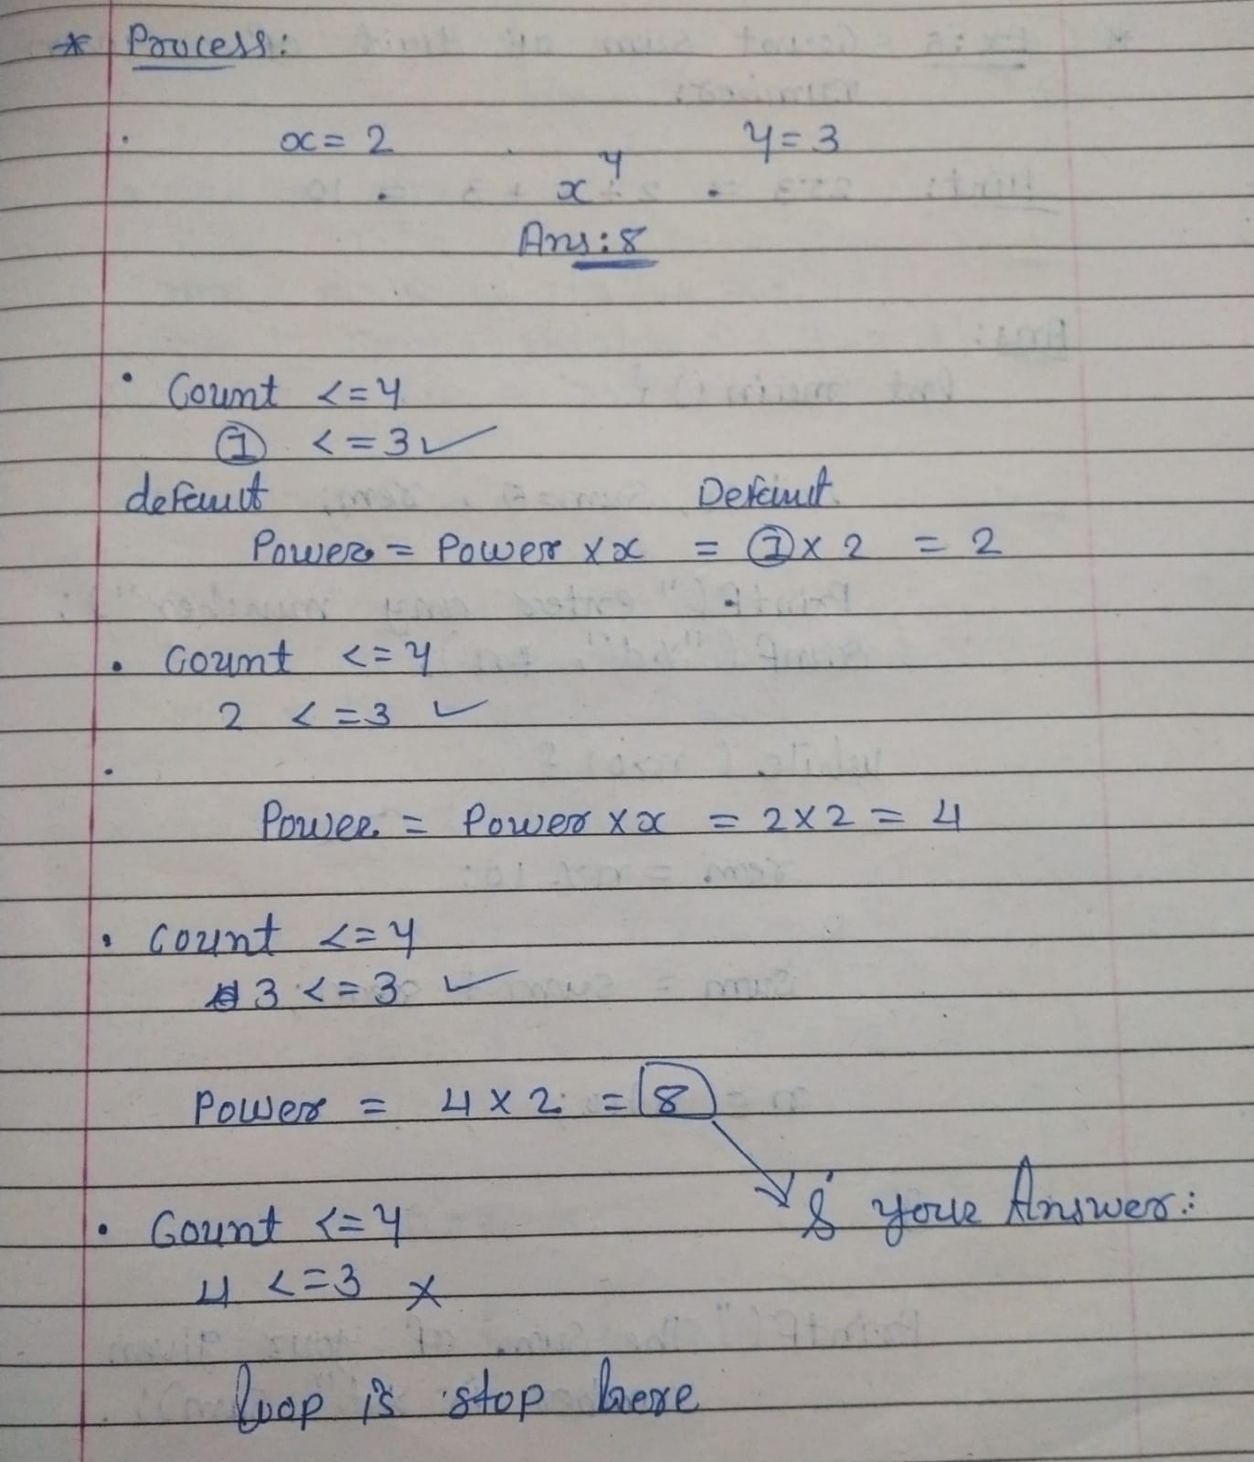

* **Output**

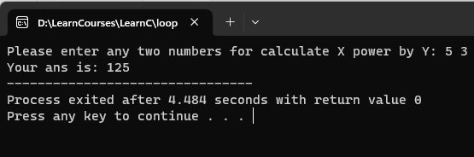

1. **Write C program to give average of n numbers.**

* **Code**

#include<stdio.h>

int main() {

int n, sum = 0, rem;

printf ("Please enter any number: ");

scanf ("%d", &n);

while (n > 0) {

rem = n%10;

sum = sum+rem;

n = n/10;

}

printf ("The sum of your given number is %d" , sum);

return 0;

}

* **Process**

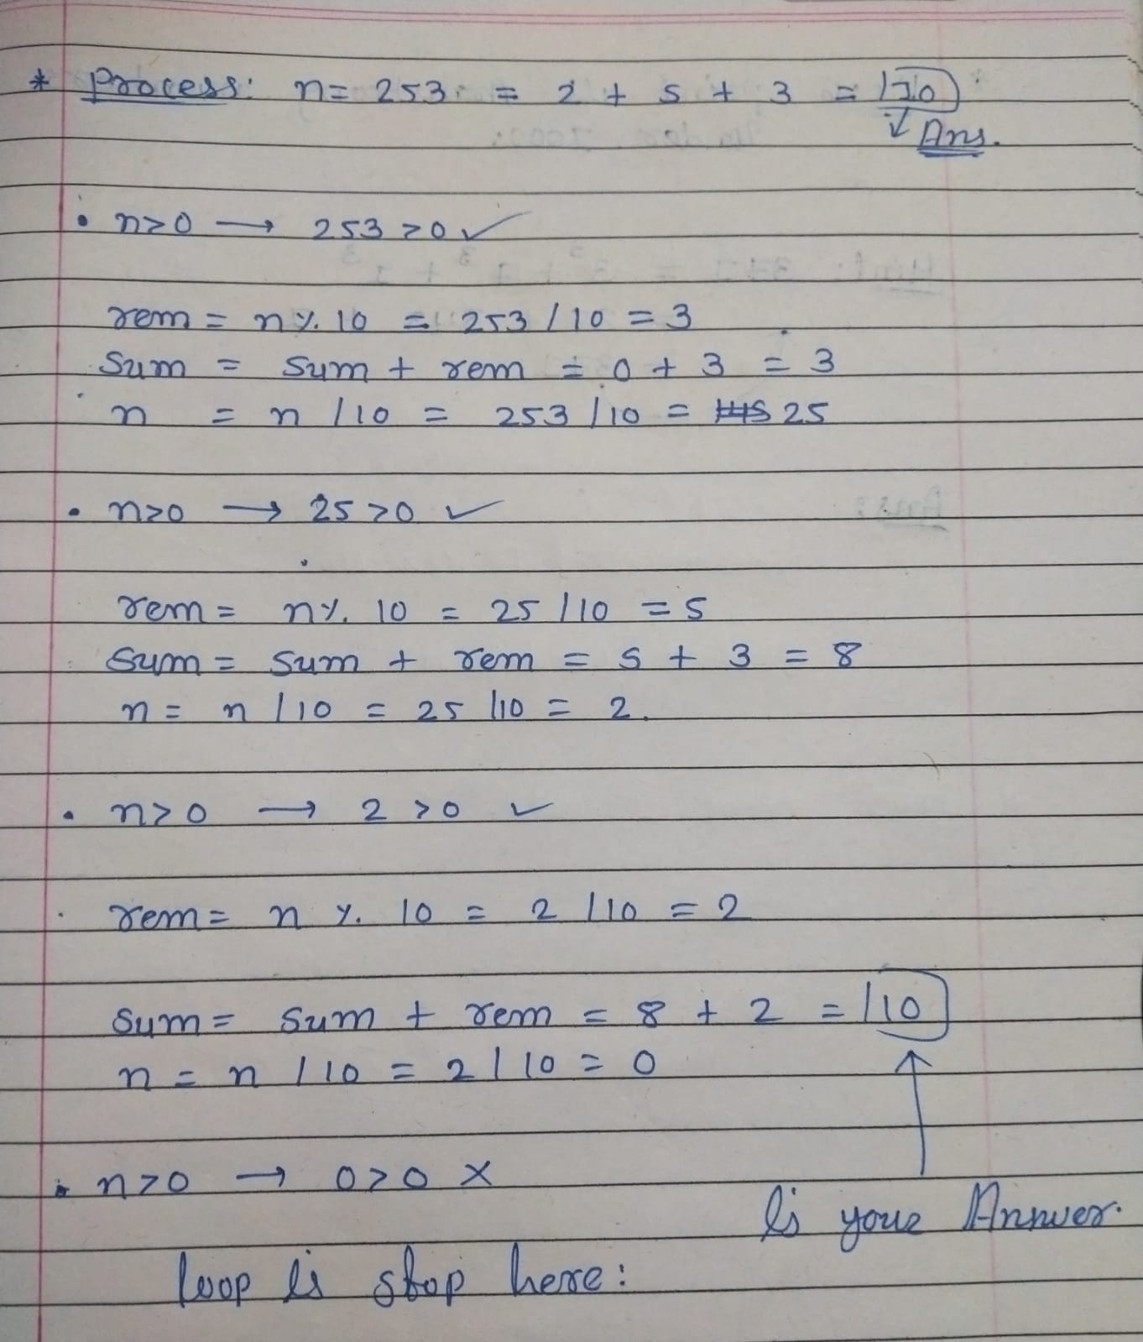

* **Output**

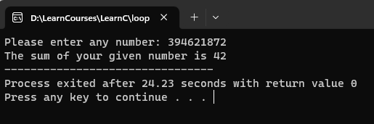

1. Write a program to print all Armstrong numbers under 1000.

* **Code**

#include<stdio.h>

int main (){

int i, rem=0, res=0, temp;

for (i = 1; i <= 1000; i++) {

temp = i;

while (temp > 0) {

rem = temp % 10;

res = res + (rem * rem * rem);

temp = temp / 10;

}

if (res == i) {

printf("%d\n", i);

}

res = 0;

}

return 0;

}

* **Output**

